

Company Overview:

In the expanding competitive landscape of Indian e-commerce, where industry giants such as Amazon and Flipkart have dominated due to their convenience and reach, Meesho emerged as a new alternative in 2015. Founded by Vidit Aatrey and Sanjeev Kumar, Meesho was a peer-to-peer social commerce platform that enabled local individuals, especially women entrepreneurs, to resell their products. This was previously done via WhatsApp and other social media channels, which limited its reach. Meesho provided a one-stop solution to this problem, along with providing affordability and local taste. Currently, with over 21 crore annual transacting users, 575 thousand sellers and a GMV (Gross Merchandise Value) OF 6.2 billion, it has positioned itself as a powerful competitor.

Structure of the Offer:

- Fresh issue up to ₹4,250 crores to fund working capital requirements, strategic investments and general corporate purposes. The size may be reduced to ₹850 crores if there is a Pre IPO-placement offer. Page 133

- An offer for sale of 105,513,839 equity shares to ensure liquidity in the market. The selling shareholders include Elevation Capital, Peak XV Partners and SoftBank, including a portion of the promoter’s stake. Page 133

- The company has set a price band of ₹105-₹115 per share for its IPO, which opens for subscription on December 3rd, valuing the company at $5.6 billion at the end of the IPO. The offering closes on December 5th and is expected to list on December 10th on BSE and NSE. Source

Key Financial Metrics:

- Revenue from operations has surged to ₹9,389.9 crores in FY25, marking a 23% increase from FY24. The company has become cash-flow positive, generating ₹539.37 crore in net operating cash. Page 409

- The company has incurred losses since its inception. While they have been cash flow positive in FY24 and FY25, the company has restated losses before exceptional items and tax of ₹147.67 crores and ₹108.4 crores for the three months ending June 30 and FY25, respectively. Page 409

- Adjusted EBITDA has increased over the last 3 years, with the current data showing a loss of ₹219.59 crores, indicating a marginal improvement in the efficiency of the business's core operations. Page 409

- Consistent negative cash flows from operations over the last 3 years, totalling ₹1,454.863 crores, have reduced the company's ability to make operational progress. Page 412

(in Indian Rupees in Million)
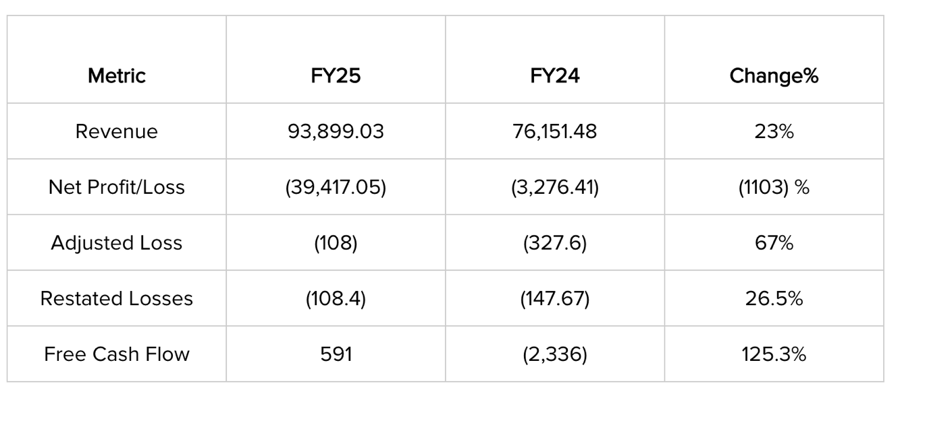

Risks associated with the business:
- Despite operational improvements, the company has incurred losses since 2015, reporting a large loss in FY25. Future profitability depends heavily on the successful execution of its future operations. Page 87
- The company has experienced high employee turnover, with attrition rates of 52.04% in FY24 and 33.94% in FY25. This could hinder the business's technological and operational aspects and indicate inefficiency.
- Meesho faces fierce competition from well-established businesses such as Amazon and the Walmart-owned Flipkart. This places continuous pressure on product pricing and customer acquisition strategies.
- The company also incurred a one-time expense of ₹130 crores as a prerequisite tax paid on behalf of investors. The logistical expenses have also increased drastically over the years, indicating a lot of pressure on its logistics platform, Valmo Page 450

Company Insights:

- The development of Meesho’s asset-light logistics platform, Valmo, has been a critical step in reducing costs. This involves local logistics partners, which lowers shipping costs and passes those savings on to sellers to maintain product affordability. They handle around 62% of the company’s shipped orders as of FY25. Page 91

- Management is focused on diversification through Horizon 2 initiatives, including the launch of new ventures such as Valmo for daily essentials and a potential digital financial services platform.

- A higher proportion of orders (76.95% in Fy25) is paid via COD. The payment method carries significant risk related to returns and logistics costs, which block the business's capital. Page 93

- The demerger of the e-commerce undertaking with Meesho Technologies Private Limited and the demerger of the Grocery Undertaking with Meesho Grocery Private Limited would increase the business's efficiency.

Market Outlook:

- The professionals have signalled a cautious status on Meesho’s IPO. The grey market premium (GMP) has surged to ₹35-36 per share based on the upper price band of ₹111. This is approximately 32% upside from the IPO price band. However, the grey market is very speculative and unreliable. At the upper end of the price band, the company is valued at approximately. $5.6 billion indicating 5.6x FY25 revenue, while the other ecommerce firms trade at 1-2x of revenue.

- Professional institutions such as Kotak Mahindra Capital, JPMorgan, Morgan Stanley, and Meesho have been labelled “A Logistics Moat Story,” emphasising the importance of Valmo in the business. This could be one reason to justify the premium.

Conclusion:

The Meesho IPO can be a defining moment for the Indian e-commerce sector, validating the scalability, innovation and benefits of its value-first model. The Horizon 2 initiatives and Valmo are just a step toward achieving market leadership and moving toward profitability. While the company is currently making strategic investments for the future, it has achieved positive free cash flow, a breakthrough in this sector. The company's long-term strategy is clear: to develop its own internal systems to reduce dependency and increase operational efficiency.

Authored by: Aryaveer Batra

Disclaimer:

This article is intended solely for information and educational purposes and does not constitute any financial, investment or legal advice. The data and analysis presented are based on publicly available information, including the company’s Red Herring Prospectus (RHP) and reputable financial news sources. Readers are advised to conduct their own research and consult with a qualified financial advisor before making any investment decisions. The author and publisher have no responsibility for any monetary losses or damages from reliance on the information contained herein.

